 

**M.V.P. SAMAJ**

K.R.T ARTS, A.M.SCIENCE AND B.H.COMMERCE

COLLEGE, GANGAPUR ROAD

NASHIK.

**A PROJECT REPORT**

**ON**

**Ice-Cream Parlour**

**Developed by**

1.Mahale Saurav Sanjay

2.Ingale Om Babasaheb

3.Nathe Rahul Nandu

B.Sc. (Computer Science)

(2023-2024)

Under the guidance of

Prof. M.R.Satpute

Department of Computer Science

**SAVITRIBAI PHULE PUNE UNIVERSITY**



M.V.P SAMAJ’S

KRT Arts, BH Commerce and AM Science College, Nashik

**CERTIFICATE**

This is to certify that

Mr. **Nathe Rahul Nandu**  (Seat No :_________ ),

of T.Y.B.Sc. (Computer Science) have / has successfully completed project titled **Ice Cream Parlour** satisfactorily as partial fulfillment of curriculum for T.Y.B.Sc. (Computer Science) Semester-VI during academic year 2023-2024.

Project Guide Head of Department

Computer Science

Internal Examiner External Examiner

**Acknowledgement**

We would like to express our special thanks of gratitude to our project guide **Prof. M.R.Satpute**, our Computer Science Head of Department **Dr. R. A. Patil** as well as our principal **Dr. R. D. Darekar** who gave us the golden opportunity to do this wonderful project of **Ice-Cream Parlour**, which also helped us in doing a lot of Research and we came to know about so many new things.

This project is substantially upgrading our skill of software development which we intend to good use in developing better system in future.

In conclusion, we would like to express our thanks to **management of K.T.H.M. College, Nashik** for providing us all the facilities which helped in completion of our project.

Finally, we extend our thanks to all **B.Sc. (Computer Science) staff**, Classmates and also thanks to **my parents** to help us all the time.

And special thanks to **my Friends** who helped us, they pointed out errors & suggested changes, which in turn helped in many ways.

Thank you all.

1.Mahale Saurav Sanjay

2.Ingale Om Babasaheb

3.Nathe Rahul Nandu

INDEX

|  |  |  |
| --- | --- | --- |
| Sr.No | Title | Page No. |
| 1. | *introduction* |  |
| 2. | Problem Definition |  |
| 3. | Need of System |  |
| 4. | Proposed System |  |
| 5. | Feasibility study |  |
| 6. | H/w and s/w requirement |  |
| 7. | Fact finding techniques |  |
| 8. | ER Diagram |  |
| 9. | UML Diagrams |  |
| 10. | Data Dictionary |  |
| 11. | Sample I/O Screen. |  |
| 12. | Conclusion |  |
| 13. | Advantages |  |
| 14. | Bibliography |  |

## Introduction

## E-commerce is fast gaining ground as an accepted and used business paradigm. More and more business houses are implementing web sites providing functionality for performing commercial transactions over the web. It is reasonable to say that the process of ordering on the web is becoming common place. The objective of this project is to develop a general purpose e-commerce store where any product (such as Amul, Natural etc.) can be bought from the comfort of home through the Internet. However, for implementation purposes, this paper will deal with an online Ice-Cream Parlour.

The Ice-Cream Parlour is a virtual store on the Internet where customers can browse the catalogue and select products of interest. The selected items may be collected in a ordering cart. At checkout time, the items in the ordering cart will be presented as an order. At that time, more information will be needed to complete the transaction. Usually, the customer will be asked to fill or select a billing address, a shipping address, a shipping option, and payment information such as Cash on Delivery and then bill is displayed to the user. The Ice-Cream Parlouris expanded permanently through new products and services in order to offer a product portfolio corresponding to the market. Private customer and business can order the selected products of the Ice-Cream Parlour service online quickly and comfortably.

Target groups of customer of the Ice-Cream Parlour are huge. The customers can have a payment option through Cash on Delivery only.order to use the load writing procedure, thecustomerregistersitself and receives a login for its purchases name. It is an Internet application.

|  |
| --- |
| **Problem Definition**  **Problem in existing system**   * The existing system is manual system. Needs to be converted into automated system. * Risk of mismanagement of data. * Less Security. * No proper coordination between different Applications and Users. * Accuracy not guaranteed. * Fewer Users - Friendly. * Not in reach of distant users.   **Solution of these problems**  The development of the new system contains the following activities, which try to automate the entire process keeping in view of the database integration approach.   * User friendliness is provided in the application with various controls. * The system makes the overall project management much easier and flexible. * There is no risk of data mismanagement at any level while the project development is under process. * It provides high level of security with different level of authentication. • Users from any part of the world can make use of the system. * New system will be much better in performance as compared to existing one.   Proposed System    Proposed system is computerized system which minimize the drawbacks of manual system. If it user friendly which helps to organization to contribute to perform the task easily.in this system for the records of many clients, we have also provide validation to all fields in form based on their data type in database.  We are avoid many buttons update, remove ,search that helps user to retrieve data. All records are correctly save in database so there are no chance of data lose. relationship of tables are well maintained.    THE ADVANTAGE OF PROPOSED SYSTEM :-  1) Retrieve information is very easy.  2) Easy to maintain details.  3) Customer satisfaction.  4) Specific daily records  5) Fast service.  6)Time saving.  7)Trustworthy. |

Feasibility Study

1. Operational Feasibility:
   * 1. The present system is easily understandable and use. Hence our system is operationally feasible
2. Technical Feasibility:
   * 1. This software is main based and hardware which is required for development
3. Economical Feasibilities**:**

* + 1. As all data at present is stored on paper which leads too loss of huge amount of paper as well as money for buying it .once the software is developed everything would be automated and less error will occur.

ER Diagram

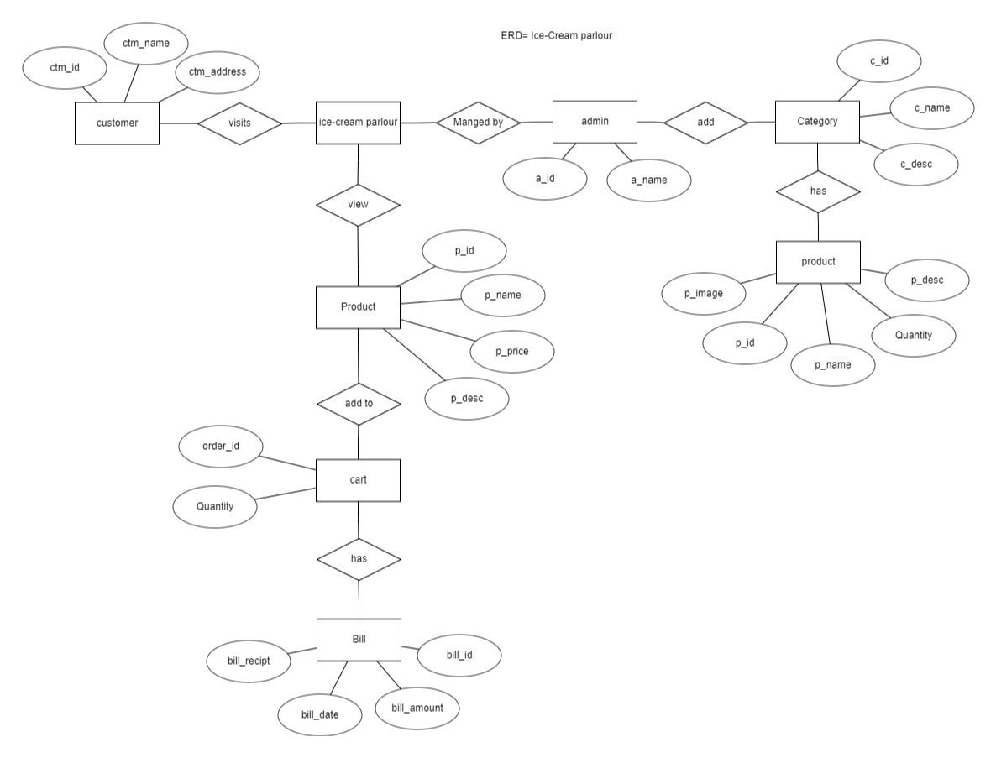

## 

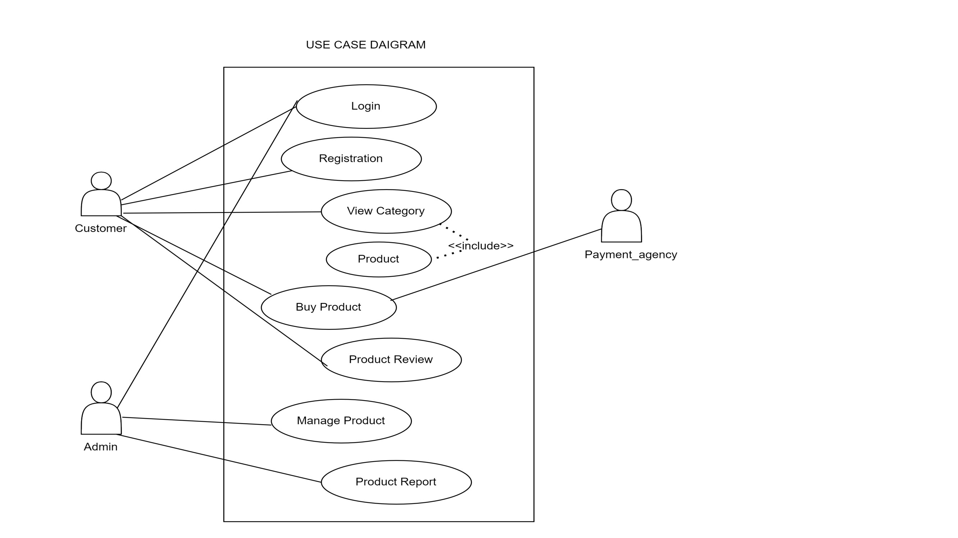

E

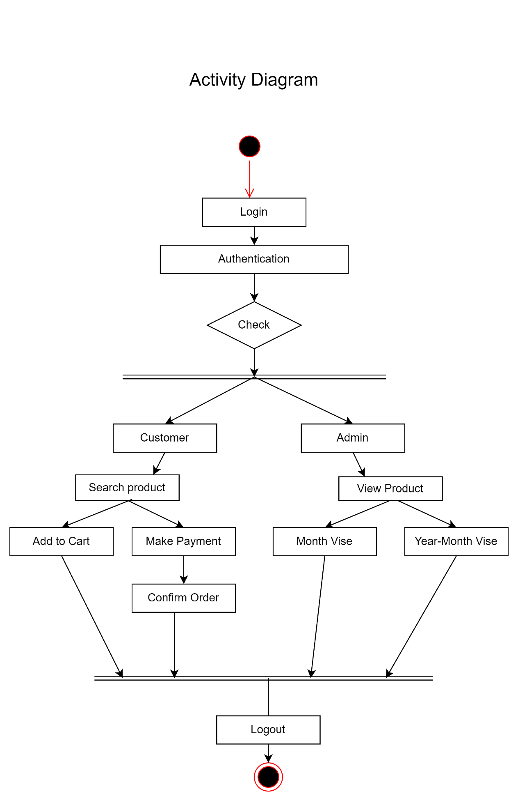

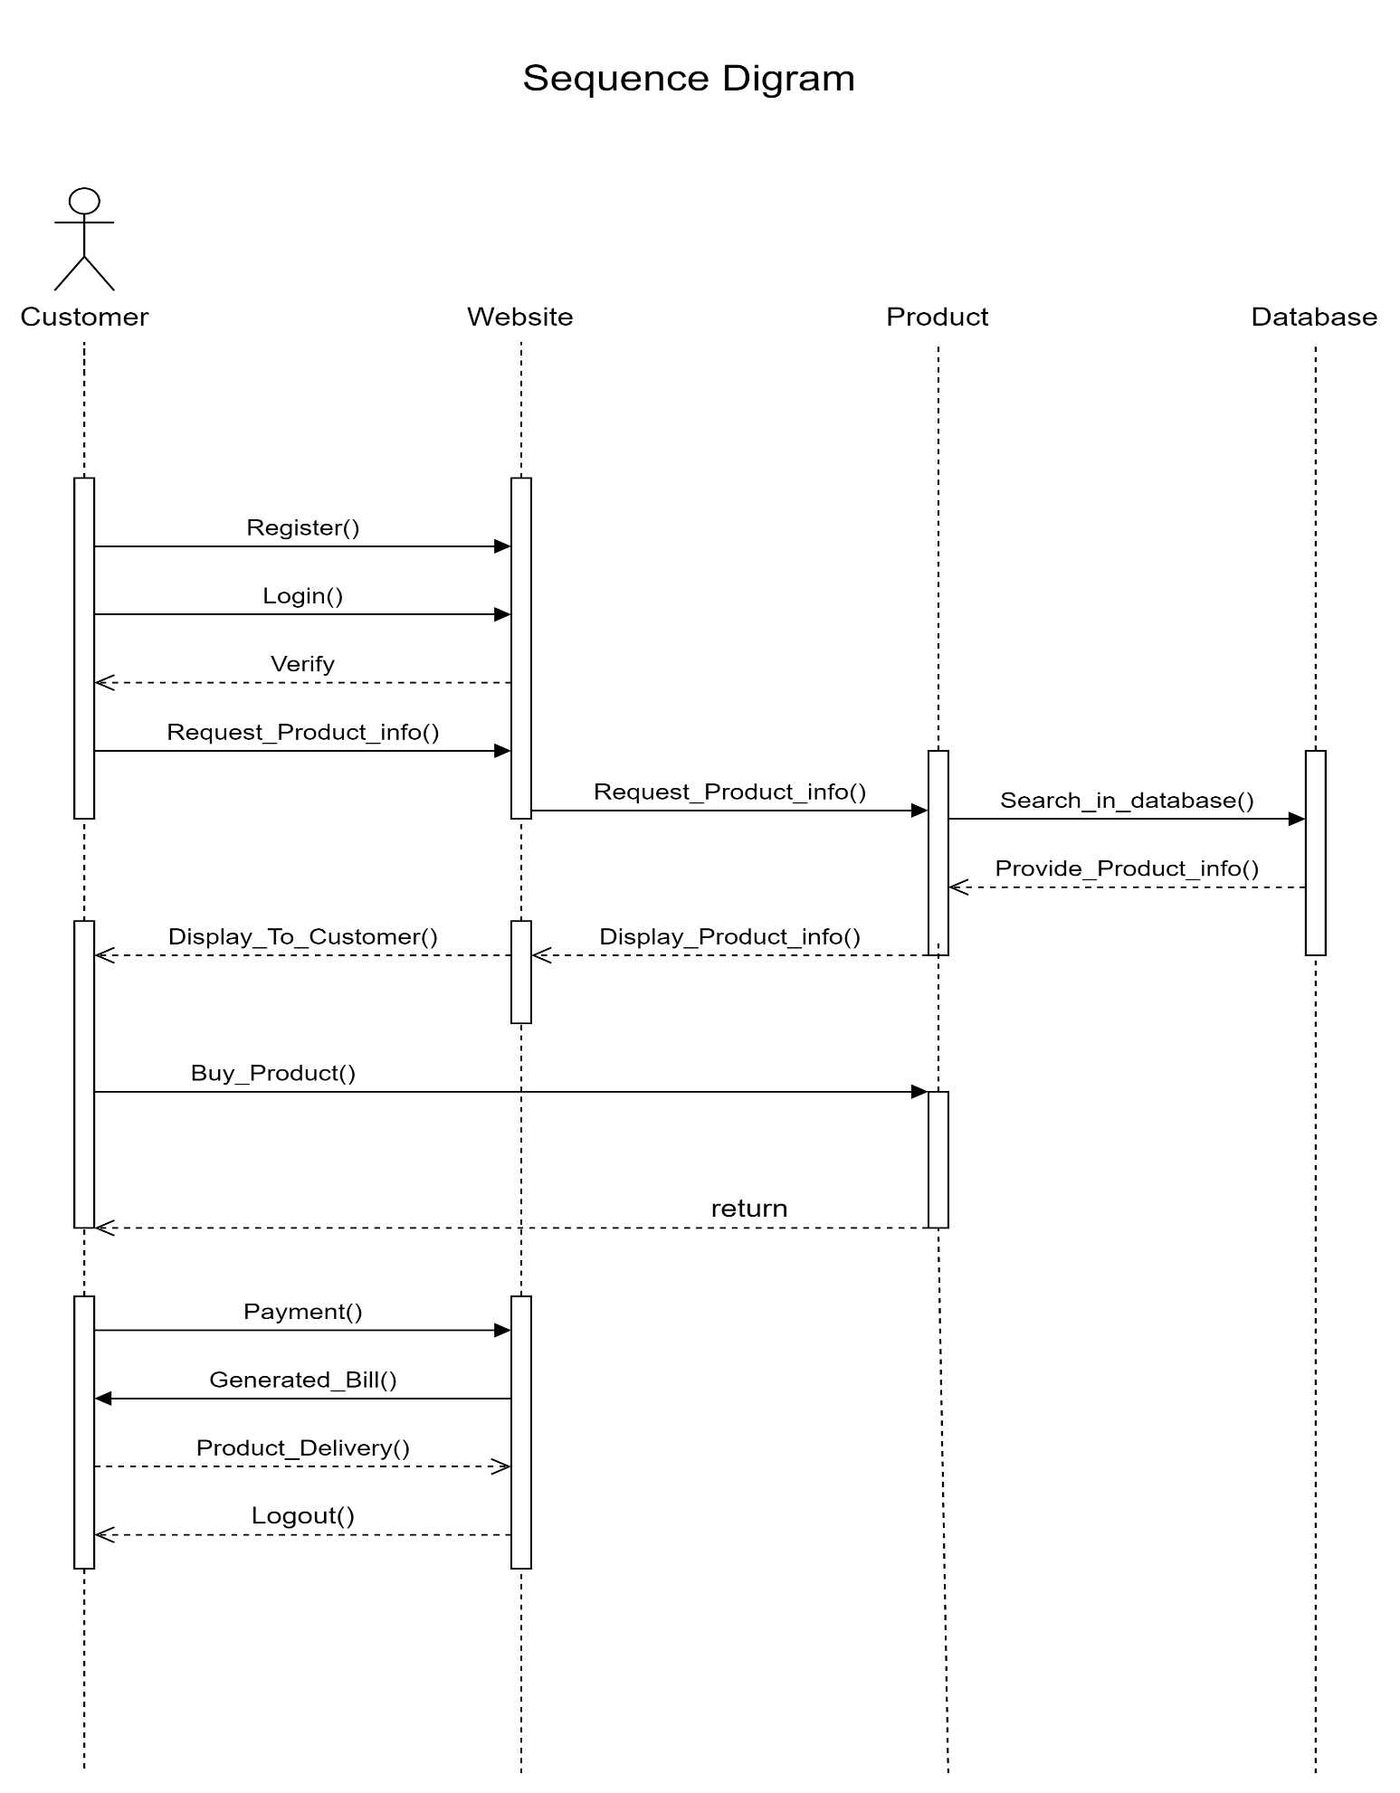

Class Digram

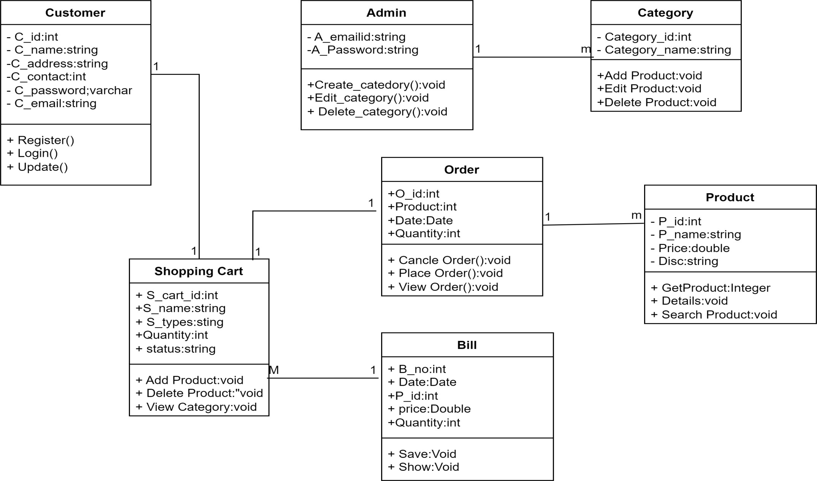

Component Diagram

**Client server**

**Database server**

**Data Dictinary**

1] Admin

|  |  |  |
| --- | --- | --- |
| **Attribute** | **Data Type** | **Length** |
| username | varchar | 20 |
| password | varchar | 100 |
| email | varchar | 20 |
| phone | int | 10 |

**2] user**

|  |  |  |  |
| --- | --- | --- | --- |
| **Attribute** | **Data Type** | | **Length** |
| User-name | Varchar | | 20 |
| address | Varchar | | 20 |
| F_name | Varchar | | 20 |
| L_name | varchar | | 20 |
| email | varchar | | 20 |
| phone no | int | | 10 |
| Id | | Int | 11 |
| password | | varchar | 30 |

3] product(dishes)

|  |  |  |
| --- | --- | --- |
| **Attribute** | **Data Type** | **Length** |
| name | varchar | 20 |
| d_Id | Int | 11 |
| category-id | Int | 11 |
|  |  |  |
| price | int | 30 |
| image | varchar | 20 |

4] Order-details

|  |  |  |  |
| --- | --- | --- | --- |
| **Attribute** | **Data Type** | **Length** | **constraint** |
| User-Name | Varchar | 20 |  |
| Id | Int | 11 | Primary key |
| Address | Varchar | 20 |  |
| phone | int | 20 |  |

**5] order-item**

|  |  |  |  |
| --- | --- | --- | --- |
| **Attribute** | **Data Type** | **Length** | **constraint** |
| Id | Int | 11 | Primary key |
| Product-id | Varchar | 20 |  |
| quantity | Int | 20 |  |
| Created-at | timestamp | 20 |  |

**6] product-category**

|  |  |  |  |
| --- | --- | --- | --- |
| **Attribute** | **Data Type** | **Length** | **contraint** |
| c_name | Varchar | 20 |  |
| desc | Varchar | 20 |  |
| C_id | Int | 10 | Primary key |

**7] profile**

|  |  |  |  |
| --- | --- | --- | --- |
| **Attribute** | **Data Type** | | **Length** |
| User-name | Varchar | | 20 |
| address | Varchar | | 20 |
| F_name | Varchar | | 20 |
| L_name | varchar | | 20 |
| email | Int | | 10 |
| phone no | int no | | 10 |
| Id | | Int | 11 |
| pass | | varchar | 30 |

Limitations

* There is no any duplicate detail of student are allow at the time of inserting the data.
* But only admin can update the details of faculty and student edit or update the their own info.

Advantages

* It is fast, efficient and reliable.
* Easily maintainable and updateable.
* Easy to use and handle.
* This application can use any person.
* Paperless storage of faculty data.

Future Scope

* Future the faculty can upload the video of their lecture on to this site and students who had missed those classes can view those videos.
* We can make an automatic attendance system in our system through face recognitions algorithm.

**CONCLUSION**

This Website project would allow our customers convenient and easy access to the site. It would save time and placing orders and doing payment becomes more simpler and it is very efficient. Hence we have designed the project to provide the user with easy navigation, retrieval of data and necessary feedback as much as possible.

A good ordering cart design must be accompanied with user-friendly ordering cart application logic. It should be convenient for the customer to view the contents of their cart and to be able to remove or add items to their cart. The E-Ice Cream Parlour application described in this project provides a number of features that are designed to make the customer more comfortable.

This project helps in understanding the creation of an interactive web page and the technologies used to implement it. The design of the project which includes Data Model and Process Model illustrates how the database is built with different tables, how the data is accessed and processed from the tables

"Online Ice-Cream Parlour" provides knowledge about the latest technology used in developing web enabled application and client server technology that will be great demand in future. This will provide better opportunities and guidance in future in developing projects independent

System Specification

**.** Hardware Requirement:

1 .Memory: 32MB and above

2 .HDD: 4 GB and above

**.** Software Requirement:

1. Language: Front end: HTML,CSS,JAVA Script,.

Back end : php

1. Operating System : Windows 10

**Bibliography**

1. **Learning php , mysql , & javascript-robin Nixon**
2. **Php for the web larry Ullman**
3. [**https://www.wikipedia.com**](https://www.wikipedia.com)